Assessing the Implications of Spousal Disparities on the Analysis of Gender Inequality in Agricultural Technology Adoption

Abstract
Closing the gender technology gap in agriculture underlies equitable agricultural development interventions. Understanding the nuances of gender disparities in technology adoption by accurately measuring adoption for men and women is pivotal for effective agricultural policy formulation. While a growing body of research has examined gender inequality in technology adoption and measurement errors in self-reported data, this study links these two domains in agriculture. By integrating intrahousehold data with DNA fingerprinting tests of improved cassava variety (ICV) adoption at the household level in Nigeria, we identified significant spousal disparities. Our analytical and empirical analyses highlight the measurement errors arising from neglecting these spousal disparities, ultimately leading to attenuated estimations in gender inequality analysis. The findings underscore the intrahousehold gender inequality and shed light on the importance of unit of analysis and participant selection in gender inequality analysis. Through a decomposition analysis, we further reveal the mechanism of the gender inequality in ICV adoption. Our study offers important implication for methodological improvements for gender in technology adoption studies, as well as for programs and policies addressing gender inequality, rural development, and food security.
Keywords: Gender inequality, spousal disparities, intrahousehold analysis, agricultural technology adoption, cassava, Nigeria

Introduction
Sustainable agricultural development in sub-Saharan Africa relies on agricultural productivity increases, yet the gender productivity gap remains pervasive and persistent (O'Sullivan et al., 2014). The consequences of gender inequalities are far-reaching, affecting not only productivity, but income, poverty levels, and even undernutrition (Peterman, 2014). Agricultural research for development is lauded as a highly effective use of public funding to enhance agricultural productivity, albeit with a large amount of heterogeneity in outcomes (Maredia and Anthony, 2010). Improved crop varieties that exhibit favorable characteristics are a key category of agricultural technology, designed to improve the efficiency of agricultural production (Ruzzante et al., 2021). Ample evidence shows, however, that agricultural technology adoption is not gender neutral. To the contrary, gender and social differences shape technology adoption (Doss and Morris, 2000; Peterman et al., 2014). This is important, as enhancing women’s ownership and control over assets, such as improved agricultural technologies, contributes to positive development outcomes at the household and individual levels (Johnson et al., 2016). Understanding the nuances of gender disparities in technology adoption is therefore pivotal for effective agricultural policy formulation.
Applied research often relies on survey data to examine gender inequality in technology adoption. Most empirical studies operating in this domain presume that self-reported data accurately reflect the true values of the variables under investigation. However, an expanding body of economic research indicates that people commonly misperceive actual conditions (Bound et al., 2001; Hu and Sasaki, 2015; Abay et al., 2019, Wossen at al., 2019, Abay, Bevis, and Barrett, 2021; Abay et al, 2023). Despite these findings, the specific impact of potential gender-related measurement error on empirical analyses addressing gender inequality remains underexplored in existing literature.
In addition, while most sex-disaggregated datasets predominantly rely on the self-reported data from household heads or individual representatives of households, this approach often overlooks the importance of spousal disparities within the household. Headship does not always reflect the decision making, nor does it reflect the experiences of women in partnership with male household heads (Peterman et al., 2014; Deere et al., 2010). Further, shifting from a more unitary household model to a collective one focused on experiences of individuals within it may miss out on key dynamics where household members jointly control resources (Doss and Quisumbing, 2020). Interviewing single individuals within households can therefore lead to incorrect conclusions about the household and dynamics therein (Fisher et al., 2010; Twyman et al., 2015).
Interviewing multiple respondents within household surveys provides richer and more nuanced understanding of what happens within these households (Doss, 2021). Recent work on spousal intrahousehold datasets reveals interesting insights on information asymmetries that shape spousal concordance on ownership and decision making in Nepal (Ambler et al., 2021); principal residence valuation in India (Doss et al., 2018); and perceptions of decision making in agriculture (Twyman et al., 2015; Anderson et al., 2017). Intrahousehold studies on technology adoption offer insight into how household members make decisions on adoption, and what affects these decisions. Recent studies have shown for example how agricultural adoption and productivity differences between female and male plot managers are explained mainly by structural effects (Tufa et al., 2022). Fisher and Kandiwa (2014) reveal significantly different adoption rates of improved maize varieties between women who are heads of households, and women who are wives of male household heads. Increasingly nuanced studies reflect the call for more intersectional analyses in agricultural research (Tavenner et al., 2022). For example, status within the household, conferred by gender but also marital status, generation, and education, is linked to adaption of improved sorghum varieties (Smale et al., 2018). Further, despite long standing debates over the use of the term household head (Buddlender ,2003), there is little exploration of married and co-living women who identify as head of the household.
Improved casava (Manihot esculenta) varieties are an important agricultural technology for Nigerian farmers. Cassava is a vital staple crop and its capacity to thrive with minimal external inputs, particularly in the face of environmental stressors such as drought (EL-Sharkawy, 2004), makes it an essential component of food security and resilience strategies (Montagnac et al., 2009). In Nigeria, cassava cultivation is predominantly carried out by smallholder farmers, both men and women (Ahmadu and Idisi, 2014). It occupies a pivotal role in the country's food economy, ranking as the primary source of carbohydrates after maize and rice (Udensi et al., 2011). Extensive efforts have been devoted to enhancing cassava production through global, regional, and national crop improvement initiatives, leading to the development and adoption of new cassava varieties (Abdoulaye et al., 2014). Yet, prior studies on the adoption of improved cassava and related technology in Nigeria offer a mixed picture on the gender-inclusiveness of data collection and the role of gender in the adoption of ICV or related technology (Table 1).

Table 1. Sampling and sex-disaggregation of previous studies of improved cassava-related technology adoption in Nigeria (non-systematic review)
Author | Sample Size | Unit of Analysis | Sex-Disaggregation | Gender-Related Results
Awotide et al., 2014 | 841 | Household | Not reported | Female headed households more likely to adopt
Apu and Nwachukwu, 2011 | 150 | Household | Not reported | Not reported
Awotide et al., 2014 | 952 | Household head | 89% male respondent  11% female respondent  89% married | Gender not significant
Agwu, Ekwueme, and Anyanwu, 2008 | 135 | Farmer | 81.5% male respondent  18.5% female respondent 73.3% married | Not reported
Nwakor et al., 2011 | 150 | Farmer | 45.3% male respondent  54.7% female respondent  70.7% married | Women more likely to adopt
Obisesan, 2014 | 482 | Household | 76.23% male respondent  23.8% female respondent | Men more likely to adopt
Udensi et al., 2011 | 510 | Farmer | 43.5% male respondent  56.5% female respondent  78.8% married | Gender not significant in  ICV adoption
Wossen et al., 2017 | 2500 | Household head | 89% male respondent  11% female respondent  30% spouses | Men are more likely to adopt ICV; Gender not significant when adoption is measured by DNA fingerprinting tests

While a growing body of research has examined gender inequality in technology adoption and measurement errors in self-reported data, this study is the first to link these two domains in agriculture. Emerging studies have shed light on the presence of measurement errors and misclassifications in self-reported data (Wossen et al., 2019; Abay et al., 2019 and 2023), while many studies have unpacked gender inequalities in technology adoption. Knowing that gender inequality in technology adoption is driven by inequality in knowledge resources, assets, and gender-related preferences, here we ask: could spousal disparities lead to systematic measurement errors related to gender and subsequently bias our understanding of technology adoption?
Addressing this question is pivotal not only for advancing our comprehension of gender disparities in technology adoption within agriculture but also for refining the methodologies employed in agricultural technology adoption gender gap analyses, thus facilitating more nuanced and accurate policy formulation in this critical domain. This study contributes to this conversation on gender gaps in agricultural technology adoption with insights on gender endogenous measurement error and its impact on regression analysis. This study also contributes by analyzing the intrahousehold endowment, coefficient, and interaction effects in gender inequality in technology adoption in agriculture.

Data
We integrated existing data sets from the Cassava Monitoring Survey in Nigeria (Wossen et al. 2017) that included an intrahousehold survey regarding the self-reported adoption of ICV and DNA fingerprinting results. The dataset encompasses the 16 Nigerian states across four regions (Southwest, Southeast, South-South, and North) that contributed at least 80% of the total cassava production. The enumeration areas (EAs) for conducting the national census in Nigeria were obtained from the national Population Commission of Nigeria. Within each EA, sample frames of a minimum of 50 cassava-growing households were established with agricultural development programs by selecting them from a list of all households engaged in cassava cultivation in the targeted states. Interviews were then conducted with household heads and two spouses, amounting to 625 households in each region. Consequently, a total of 2,500 randomly selected cassava-growing households were interviewed. Interviews were conducted with both the designated household head and an additional household member.
For this analysis, households were only included, if both respondents reported that: their relationship to the household head was ‘self’ or ‘spouse’, their marital status was married, and they were living with their spouse. As a result of these criteria, 29 households were excluded, leaving a final sample of 729 households, consisting of 1,458 men and women (Table 2). Within this analysis, there are 13 instances of women self-identified as household heads and three cases among the 13 households where men are self-identified as spouses. Among these responses, the wife in one household responded as the household head, and the husband responded as the spouse. In ten households, both respondents identified themselves as the household head, and in two households both participants identified as spouses.

Table 2. Summary statistics for the household cassava dataset
Category | Variable | Husbands |  | Wives
 |  | N | % | N | %
Marital Status | Married, living with spouse/s | 729 | 100.00% | 729 | 100.00%
Relationship to Household | Head | 726 | 99.59% | 13 | 1.80%
 | Spouse | 3 | 0.41% | 716 | 98.20%
Main Occupation | Farmer (crop and livestock) | 588 | 80.70% | 490 | 67.20%
 | Self-employed off farm | 81 | 11.10% | 160 | 21.90%
 | Other | 60 | 8.20% | 79 | 10.90%
Zone | 1 (North) | 186 | 25.50% | 186 | 25.50%
 | 2 (South-South) | 238 | 32.60% | 238 | 32.60%
 | 3 (Southeast) | 165 | 22.60% | 165 | 22.60%
 | 4 (Southwest) | 140 | 19.20% | 140 | 19.20%

Each farm is typically responsible for multiple plots, with the average farm managing between two and three plots across the four regions, ranging from 1 to 18 (Table 3). The survey inquired about the 'number of ICV plots managed by husbands, 'number of ICV plots managed by wivew, and the 'number of ICV plots jointly managed'. For analytical purposes, we transformed the 'number of ICV plots managed by husbands and 'number of ICV plots managed by wives' to a binary variable (1: adoption; 0: otherwise) to determine the ICV adoption within the plots managed by either husbands or wives.

Table 3. Summary of plots by household
ZoneID | Count | Mean | Std | Min | Max
North | 186 | 2 | 1.29 | 1 | 9
South-South | 238 | 2 | 1.25 | 1 | 6
Southeast | 165 | 3 | 2.14 | 1 | 18
Southwest | 140 | 3 | 1.35 | 1 | 9
Note: Summary statistics generated based on husband self-reported data.

In the CMS survey, DNA fingerprinting analysis was conducted on leaf samples collected from each identified cassava variety within farm plots. The DNA fingerprinting technique is a critical component of our study, ensuring precise measurement of household-level ICV adoption. Although the collection of leaf samples was recorded at the plot level to identify the varieties planted, the DNA tests does not provide details to correlate the plots managed by husbands/wives with the plot-level DNA testing results, due to the absence of plot ID information linked to plots managed by specific household members. Therefore, while DNA testing results are invaluable for confirming a household’s adoption of ICVs (Rabbi et al., 2015; Maredia et al., 2016, Wossen at al., 2019), they do not extend to individual household member’s plot-level verification.

Empirical framework
This section outlines the theoretical framework that highlights potential biases in regression analysis resulting from the oversight of spousal discrepancies in self-reported data. Following this, we present a decomposition method tailored to individually disaggregated spousal data, which is instrumental in dissecting the underlying mechanisms contributing to these disparities between spouses.

The impact of non-classical measurement error in binary response models
In this section, we develop the theoretical framework to explicitly discuss the bias in gender inequality analysis resulting from non-classical measurement error due to systematic spousal disparities, including instances where husbands systematically overreported and/or wives underreported adoption. Non-classical measurement error (NCME) is term used in econometrics to describe a situation where errors in measurement are correlated with the true variables of interesting, as opposed to classical measurement error (CME) where errors are independent of the true values.
As summarized in a meta-analysis of the empirical literature on adoption of agricultural technology (Ruzzante, Labarta, and Bilton, 2021), adoption studies often applied correlational analysis to explain adoption behavior as a function of variables gathered through surveys:
where represents the observed adoption behavior reported in survey data, is a matrix of explanatory variables, such as socio-economic, personality, farm management, and financial variables, is the coefficient vector estimated by the regression model, and is independently distributed from a standard normal distribution.
Observable adoption behavior is commonly measured by a binary variable: for adoption and for non-adoption. In the context of a binary response model, such as probit or logistic regression analysis, eq. (1) is estimated as:
Where denotes the cumulative distribution function (cdf) function. In the presence of measurement errors in the self-reported adoption data, we introduce the probabilities of false positives () and false negatives (), as indicated by:
Then the estimated marginal effects based on the observed data, as described by Hausman, Abrevaya, and Scott-Morton (1998), are represented as follows:
In the absence of misclassification, , and eq. (4) remains unbiased:
In the presence of systematical spousal disparities, such as household adoption behavior being systematically underreported by wives () in the self-reported data, , NCME arises. Assuming that there is no measurement error related to the covariates X, , then the estimated marginal effects are proportional to the true marginal effects:
Consequently, eq. (6) reveals that the estimates are attenuated when one gender systematically underreports the adoption.

The Blinder-Oaxaca decomposition method
In this section, we introduce the Blinder-Oaxaca decomposition method which disentangles group differences into components. As summarized in Peterman et al. (2014), most technology adoption analyses have relied on bivariate response models. However, such models often employ a dummy variable to test differences between male and female respondents and do not provide a nuanced breakdown of gender inequality into its constituent components.
The Blinder-Oaxaca approach with binary dependent variable was originally developed by Fairlie (2005). It is easy to apply based on the binary response modeling results to decompose inter-group differences (Fitzenberger, Kohn, and Wang, 2006). In this study, we label the two spousal groups as Group W and Group H for wives and husbands. The mean outcome difference to be explained (). Following eq. (1), the decomposition of a binary response model is (Oaxaca and Ransom, 1994):
Where is a weighted average of the coefficient vector of and . The eq. (8) can be written as:
Where is a weighting matrix and I is an identity matrix.
Where represents a conditional expectation, and is the conditional expectation of evaluated at the parameter vector . The estimations of the conditional expectation in probit models follow the specifications proposed by Fitzenberger, Kohn, and Wang (2006). Then, as Daymont and Andrisani (1984) proposed, we can simplify the eq. (10) to
In eq. (11), the endowments term represents the contribution of differences in explanatory variables across groups, and the coefficients term is the part that is due to group differences in the coefficients. The interaction term accounts for the fact that cross-group differences in explanatory variables and coefficients can occur at the same time.

If I well understood the extension access, access to extension increase the probability of over reported ? If so, that, that could be presented because of the influence of the extension on farmers? For example, they can be told they are harvesting sth that farmers really don’t ?

Any specific wife or husband features that mostly could explain the gap? I.e. age, education?
Not sure if that could be capture in the Oaxaca decomposition

Results
In this section, empirical analysis is developed to identify the potential systematic spousal disparities and to demonstrate the bias in gender inequality analysis due to the NCME, followed by the gender decomposition results.

Systematic spousal disparities
We first simulated household-level ICV adoption rates, varying the proportions of responses from wives to represent household adoption behavior based on self-reported data. The adoption rate is measured as the ratio of households with ICV adoption to the total number of households, relying on self-reported data from either selected husbands or wives to represent household adoption. We conducted 500 iterations for each proportion of wives' responses, ranging from 0% to 100% in 5% increments, to ensure robustness.
As the proportion of wives' representation increased, the ICV adoption rate exhibited a linear reduction (Figure 1a). This simulation suggests that a higher rate of wife respondent participation correlates with a greater likelihood of lower reported adoption rates. We then repeated this analysis with only five iterations to visualize the variation in collected data (Figure 2a). Figure 2a reveals that, even with the same proportion of wives among the respondents, the adoption rate can vary.
The fluctuation in adoption rates also exhibits regional disparities. Zone 4 (Southwest) has the highest adoption rate (79%), while Zone 3 (Southeast) has the lowest adoption rate (50%), independent of the representation rate of wife respondents. Zone 1 (North) is the only zone that shows an increment in the adoption rate with an increase in percentage of wife respondents, while in the other zones, the adoption rate gradually decreases (Figures 1b and 2b). These findings underscore the need for more nuanced analyses of ICV adoption data and highlight the systematic under/overreporting of ICV adoption by wives and husbands.

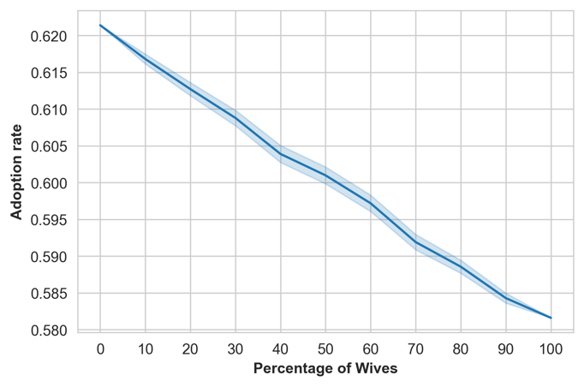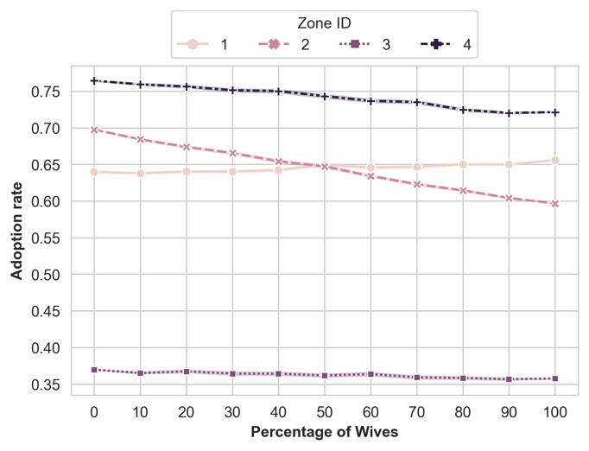
- Household adoption rate | - Household adoption rate

Figure 1. The Monte Carlo simulation of household adoption (500 iterations)
Note: Panel a depicts the Monte Carlo simulation of household adoption rates. 500 iterations are constructed for each wife respondent percentage, ranging from 0 to 100% in 5% increments. Panel b provides a breakdown of the same data but summarized by region, where zone 1-4 correspond to the north, south-south, southeast, and southwest regions, respectively.

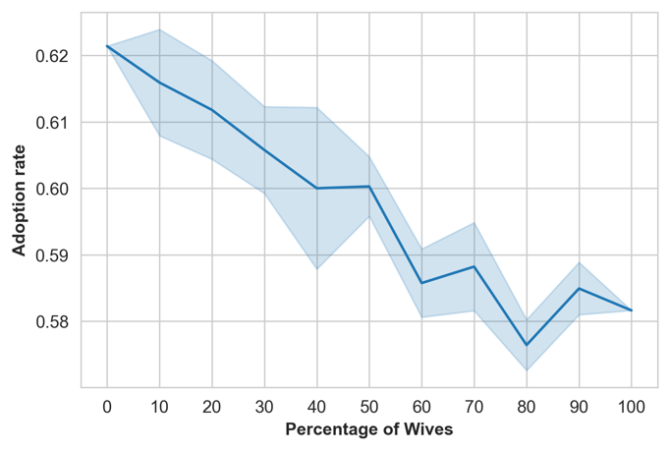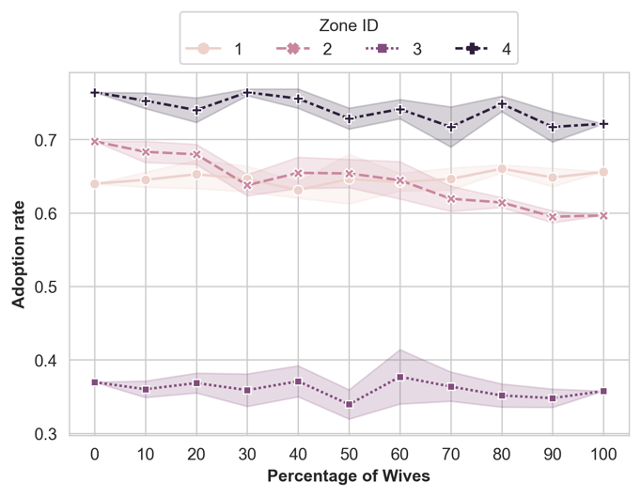
Household adoption rate | Household adoption rate

Figure 2. The Monte Carlo simulation of household adoption (5 iterations)
Note: Panel a depicts the Monte Carlo simulation of household adoption rates. 5 iterations are constructed for each wife respondent percentage, ranging from 0 to 100% in 5% increments. Panel b provides a breakdown of the same data but summarized by region, where zone 1-4 correspond to the north, south-south, southeast, and southwest regions, respectively.

Table 4 shows that the mean of the ICV adoption rate of the intrahousehold dataset resulted from the DNA fingerprinting tests and self-reported by husbands and wives. We conducted paired t-tests to assess the concordance between spouses and the agreement between self-reported data and DNA fingerprinting results. A summary of the paired t-test results is provided in the last three columns of Table 4. These results reveal statistically significant spousal disparities in reporting household ICV adoption as wives consistently underreported household ICV adoption in comparison to both husbands and DNA testing results. The gender disparities in household ICV adoption are also visually depicted in the kernel density plot (Figure 3). These findings underscore the presence of NCME in self-reported data due to gender disparities within households.
Additionally, we conducted a paired t-test and observed no statistically significant difference between the DNA-fingerprinted data and households where wives identified themselves as household heads (t-statistic: -0.433, P-value: 0.673). It is noteworthy that both husbands and wives who identified as household heads reported ICV adoption that aligns with the DNA testing results. However, it's important to acknowledge that only 2% of wives (n=13) identified themselves as household heads, in contrast to over 99% of husbands. Consequently, drawing robust conclusions is challenging. Nevertheless, these results imply that the position of household head within households where cassava cultivation is the primary activity is more likely to lead to the identification of ICVs that align with corresponding DNA analysis.

Table 4. Descriptive statistics and results from the test and mean differences by gender
 | DNA | Husbands | Wives | Paired t-test
 | [1] | [2] | [3] | [1]-[2] | [1]-[3] | [2]-[3]
ICV adoption (1: have adopted ICVs; 0: otherwise) | 0.645 | 0.621 | 0.582 | 0.977 | 2.598*** | 2.224**
Managed plots
number of ICV plots managed by husbands |  | 0.978
number of ICV plots managed by wives |  |  | 0.276
Joint Managed |  | 1.414 | 1.656
Membership of a coop
Household (reported by household heads) |  | 0.262 | 0.296
Husband Only |  | 0.067
Wife Only |  |  | 0.029
Credit Access
Household (reported by household heads) |  | 0.451 | 0.379
Husband Only |  | 0.112
Wife Only |  |  | 0.033
Extension Access
Household (reported by household heads) |  | 0.444 | 0.287
Husband Only |  | 0.222
Wife Only |  |  | 0.008
Age |  | 50.543 | 40.435
Education |  | 9.342 | 8.029
Notes: Robust standard errors in parentheses ***p < 0.01, **p < 0.05, *p < 0.1.
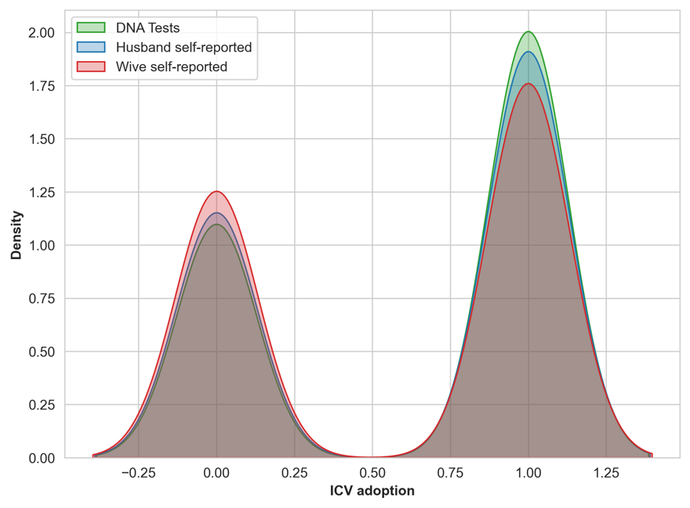

Figure 3. The Kernal density plot of self-reported ICV adoption and DNA fingerprinted data
Next, to explicitly demonstrate the consequence of NCME in gender inequality analysis, we separated the intrahousehold dataset into the wife and husband datasets to test the structural differences between the two datasets. Table 5 summarizes the regression results derived from the probit model, which compares self-reported adoption and DNA fingerprinted for both husbands and wives. The regression results show that there is a positive relationship between coop members and household ICV adoption reported by husbands; however, no statistically significant relationship was found using wives’ self-reported dataset. It is observed that the estimates obtained from the wives’ self-reported data consistently exhibit attenuated estimates in comparison to those derived from the male cohort, as outlined in eq. (7).

Table 5. Regression results (Probit model)
 | Husbands |  | Wives
 | Self-reported | DNA | Self-reported | DNA
Joint Coop | 0.130** | -0.009 | 0.076 | -0.062
 | (0.063) | (0.179) | (0.112) | (0.059)
Household Credit | -0.040 | -0.025 | -0.008 | 0.103
 | (0.065) | (0.122) | (0.102) | (0.142)
Extension Access | 0.432*** | 0.232** | 0.079 | -0.111
 | (0.064) | (0.096) | (0.113) | (0.137)
Consumption (%) | -0.002 | -0.001 | -0.004*** | 0.003
 | (0.004) | (0.007) | (0.001) | (0.002)
Zone 1 | -0.116*** | 0.194*** | -0.238*** | -0.156***
 | (0.027) | (0.032) | (0.046) | (0.049)
Zone 3 | -0.655*** | -0.600*** | -0.474*** | -0.574***
 | (0.026) | (0.100) | (0.025) | (0.042)
Zone 4 | 0.317*** | 0.335*** | 0.346*** | 0.329***
 | (0.069) | (0.110) | (0.057) | (0.051)
Age | 0.003 | 0.003 | 0.008*** | 0.015***
 | (0.005) | (0.008) | (0.003) | (0.003)
Education | -0.009 | 0.006 | 0.002 | 0.012
 | (0.006) | (0.020) | (0.023) | (0.017)
Household size | 0.071*** | 0.049** | -0.003 | -0.014
 | (0.014) | (0.022) | (0.013) | (0.033)
Main occupation: Salaried employment | -0.137 | -0.087 | 0.302** | -0.009
 | (0.246) | (0.302) | (0.141) | (0.314)
const | -0.046 | -0.169 | 0.146 | -0.232
 | (0.155) | (0.390) | (0.355) | (0.185)
N | 729 | 729 | 729 | 729
Notes:
1. The dependent variables are the self-reported ICV adoption and DNA fingerprinted. The Self-report column summarizes the results based on the male and female self-reported data, respectively. On the other hand, the DNA test summarizes the results of when the DNA test is assumed as the dependent variable for the husbands and wives self-reported data.
2. (*, **, ***) indicate statistical significance at the 10%, 5%, and 1% level.
3. Standard errors are clustered by region and reported in parentheses.

Gender inequalities in technology adoption
The dependent variable in the decomposition analysis is the ICV adoption in the plots that are managed by husbands and wives separately. The DNA fingerprinted data are not applied in this gender decomposition analysis as the DNA tests assessed household-level adoption, which does not distinguish between husbands and wives managed plots. To address the issue of measurement error and to analyze gender differences, our focus shifts to plot-level data in the following empirical analysis of gender inequality in technology adoption. This approach allows for a distinct comparison of plots managed by husbands and wives.

Table 6 presents the Blinder-Oaxaca decomposition results of the spousal gap in ICV adoption. The adoption rate of ICV in separately managed plots is 0.17 and 0.65 for the wife and husband plot manager groups, respectively, indicating a notable difference of 0.48 between the two groups. The adoption rate for this analysis is lower than the household adoption rate because the decomposition analysis only focuses on plots managed by either husbands or wives to identify the gender gap in technology adoption. In addition to these separately managed plots, it is important to acknowledge that households also have plots jointly managed by both spouses.
The decomposition results suggest that the spousal adoption gap was primarily attributed to the differences in coefficients, as the overall coefficient effect is 0.43, the endowment effect is 0.02, and the interaction effect is 0.04 (detailed in Table 6). Notably, the breakdown of endowment effects illustrates that wives have less access to extension services compared to male farmers (Table 6). Both cooperative memberships and extension services demonstrate a diminished impact on wives’ ICV adoption compared to husbands.

Table 6. The Blinder-Oaxaca decomposition results in gender inequality
 | Wife plot manager | Husband plot manager | Gap
Mean by gender | 0.167 | 0.647 | -0.480
 | Endowments | Coefficients | Interaction
Aggregate decomposition | -0.019 | -0.426 *** | -0.035
 | (0.046) | (0.058) | (0.055)
Share of the gap | 3.96\% | 88.75\% | 7.29\%
Detailed decomposition
constant | 0.000 | -0.547 ** | -0.000
 | (0.000) | (0.252) | (0.000)
Joint Coop | 0.000 | -0.029 | -0.000
 | (0.004) | (0.025) | (0.004)
Household Credit | 0.005 | 0.018 | -0.003
 | (30.007) | (0.046) | (0.008)
Extension Access | -0.032 ** | -0.094 ** | 0.033 *
 | (0.016) | (0.047) | (0.018)
Consumption (%) | 0.004 | 0.136 | -0.004
 | (0.004) | (0.091) | (0.005)
Zone 1 | -0.000 | 0.001 | 0.000
 | (0.002) | (0.020) | (0.002)
Zone 3 | -0.000 | 0.017 | 0.000
 | (0.003) | (0.024) | (0.003)
Zone 4 | -0.000 | 0.040 ** | 0.000
 | (0.004) | (0.016) | (0.004)
Age | 0.027 | 0.386 | -0.077
 | (0.036) | (0.239) | (0.048)
Education | -0.009 | -0.015 | 0.002
 | (0.014) | (0.107) | (0.016)
Household size | -0.014 * | -0.245 ** | 0.015
 | (0.008) | (0.103) | (0.009)
Salaried employment | 0.000 | -0.002 | -0.001
 | (0.004) | (0.012) | (0.005)
(Base) | 0.000 | -0.094 *** | 0.000
 | (0.010) | (0.029) | (0.008)
Notes:
1. The dependent variables are the self-reported ICV plots each gender manages.
2. (*, **, ***) indicate statistical significance at the 10%, 5%, and 1% level.
3. Bootstrap standard errors.

Conclusion
This study has made contributions in understanding intrahousehold disparities in agricultural technology adoption, systematic measurement error and mechanisms of gender inequalities in ICV adoption. By connecting a theoretical model and empirical analysis, we have illuminated the nuances of non-classical measurement errors related to gender in agricultural practices, which have potentially profound implications for agricultural technology adoption research.
First, we demonstrate a systematic false negative rate associated with in relation to technology adoption. The linear relationship between the rate of wife respondents included in the simulated dataset, and the reduction in adoption rate implies that respondent selection and study design influence the adoption rates. This could explain the large variation in ICV adoption rates we feature in Table 1. Our results strongly support the call for data best practices around intentionally including more women as respondents regardless of their household headship status (Doss, 2021). These results draw attention to the need for more consistent and robust study design approaches to better understand adoption patterns around ICV.
Second, we uncover differential endowment and systematic drivers of improved variety adoption decisions. There is a wealth of literature looking at the endowment and systematic drivers of agricultural productivity (Backiny-Yetna and McGee, 2015; Bello et al, 2021, Addai, Lu and Temoso, 2021). Our decomposition analysis contributes to this space by identifying that systematic differences in access to agricultural education, extension and financial resources contribute to a lower rate of ICV adoption between spouses. Systematic bias and inequality in extension systems and financial resources are well document. Further, access to education and extension are important determinants to improved variety adoption (Ruzzante et al., 2021; Acevedo et al., 2020). What we demonstrate is how these systems have a direct effect on ICV adoption, and differential from individual endowment differences. Designing interventions to better meet the needs of women farmers should not only focus on their individual capabilities and endowments, but rather on these systematic affects.
Third, our results unveil that the zone in which respondents are located mirrors the literature on cassava adoption and agricultural productivity. The administrative zones in which respondents reside has been shown to be a significant driver of cassava trait preferences as well as adoption decisions. Oseni et al. (2015) shows differential structural and endowment affects driving gender productivity gaps in Nigeria. Teeken et al. (2018 & 2021) demonstrate location as the primary driver of cassava trait preference differences in Nigeria, explaining more variation than gender of the respondent, poverty and food security level of the household. Furthermore, Takeshima (2018) demonstrated that proximity to plant breeding institutes in Nigeria positively impacted agricultural productivity and technical efficiency of farm households. Women’s roles in cassava production, processing and marketing vary regionally in Nigeria, with women playing a prominent role in the South East and South-South as men engage more in off-farm activities (Korieh, 2010; Osuji et al., 2017). Given this cumulative evidence, we support the call of Oseni et al. (2015) to better tailor that agricultural development policy around regions, as well as Tavenner et al. (2022) to bring more intersectional analyses to agricultural research programs.
Most importantly our results bolster much needed attention to intentional research design, and respondent selection with regards to the unit of analysis. Doss (2021) draws attention to the perils of only focusing on individual and how this loses sight on the complex web of relationships that drive individual behavior. She further accentuates the need to move away from the narrow view of the household through focus on only spousal datasets for intrahousehold studies, which miss out on intergenerational relationships and dynamics that are equally important (Doss, 2021). Plot level analysis is increasingly normative in large survey panels, for example LSMS-ISA, but plot level data can be problematic if not examined through the lens of land rights and gender norms around plot management and farming more broadly (Doss, 2018). Using headship as a gender indicator is not necessarily indicative as to who actually makes decisions for agricultural production, with women in male-headed households make production decisions often jointly with their spouses (Peterman et al., 2010; Deere et al., 2009). This is also true for cassava producing households, where women household heads had differential cassava trait preferences than women who were spouses of male household heads (Chiwona-Karltun et al., 1998; Teeken et al., 2021). Our results make an important, and slightly contradictory contribution to this literature. We show that responses from women who are household heads are more in line with the results of the DNA fingerprinted data. The knowledge and decision-making endowments of a woman how is a household head may explain this greater apparent accuracy. This result supports the need for more nuanced data collection in agricultural technology adoption studies to balance data collection the multitudes of women’s roles as household heads, spouses and plot managers.
In conclusion, our study reinforces the necessity of gender-responsive agricultural policies and services based on representative and informed data. Precision research depends on inclusive representation and empowered participation to ensure agricultural development is effective and efficient for everyone. This not only promotes gender equality but also has the potential to significantly boost agricultural productivity and development.

Funding Acknowledgement:
The authors declare financial support was received for the research, authorship, and/or publication of this article. We acknowledge the support and funding of the CGIAR Excellence in Breeding (EiB) Platform.

References
Abay, Kibrom A, Abate, Gashaw T, Barrett, Christopher B, and Bernard, Tan- guy. Correlated non-classical measurement errors,‘second best’policy infer- ence, and the inverse size-productivity relationship in agriculture. Journal of Development Economics, 139:171–184, 2019.
Abay, Kibrom A, Bevis, Leah EM, and Barrett, Christopher B. Measurement error mechanisms matter: Agricultural intensification with farmer mispercep- tions and misreporting. American Journal of Agricultural Economics, 103(2): 498–522, 2021.
Abay, Kibrom A, Wossen, Tesfamicheal, Abate, Gashaw T, Stevenson, James R, Michelson, Hope, and Barrett, Christopher B. Inferential and behavioral implications of measurement error in agricultural data. Annual Review of Resource Economics, 15:63–83, 2023.
Abdoulaye, Tahirou, Abass, A, Maziya-Dixon, B, Tarawali, G, Okechukwu, R, Rusike, Joseph, Alene, A, Manyong, V, and Ayedun, B. Awareness and adoption of improved cassava varieties and processing technologies in nigeria. Journal of Development and Agricultural Economics, 2014.
Acevedo, Maricelis, Pixley, Kevin, Zinyengere, Nkulumo, Meng, Sisi, Tufan, Hale, Cichy, Karen, Bizikova, Livia, Isaacs, Krista, Ghezzi-Kopel, Kate, and Porciello, Jaron. A scoping review of adoption of climate-resilient crops by small-scale producers in low-and middle-income countries. Nature plants, 6 (10):1231–1241, 2020.
Addai, Kwabena Nyarko, Lu, Wencong, and Temoso, Omphile. Are female rice farmers less productive than male farmers? micro-evidence from ghana. The European Journal of Development Research, pages 1–43, 2021.
Agwu, AE, Ekwueme, JN, and Anyanwu, AC. Adoption of improved agricul- tural technologies disseminated via radio farmer programme by farmers in enugu state, nigeria. African journal of biotechnology, 7(9), 2008.
Ahmadu, Joyce and Idisi, PO. Gendered participation in cassava value chain in nigeria. Merit Research Journal, 2(11):147–153, 2014.
Ambler, Kate, Doss, Cheryl, Kieran, Caitlin, and Passarelli, Simone. Spousal concordance in joint and separate households: Survey evidence from nepal. World Development, 151:105744, 2022.
Anderson, C Leigh, Reynolds, Travis W, and Gugerty, Mary Kay. Husband and wife perspectives on farm household decision-making authority and evidence on intra-household accord in rural tanzania. World development, 90:169–183, 2017.
Apu, U and Nwachukwu, I. Effect of adoption of improved cassava varieties on farmers’ income in abia state, nigeria. Journal of Agriculture and Social Research (JASR), 11(2):155–160, 2011.
Assfaw Wossen, Tesfamicheal, Girma Tessema, G, Abdoulaye, Tahirou, Rabbi, Ismail Y, Olanrewaju, AS, Bentley, Jeffery, Alene, Arega, Feleke, Shiferaw, Kulakow, PA, Asumugha, GN, et al. The cassava monitoring survey in nigeria. 2017.
Awotide, B, Abdoulaye, Tahirou, Alene, A, and Manyong, Victor M. Assessing the extent and determinants of adoption of improved cassava varieties in southwestern nigeria. 2014.
Backiny-Yetna, Prospere, McGee, Kevin, and Mcgee, Kevin Robert. Gender dif- ferentials and agricultural productivity in niger. World Bank Policy Research Working Paper, (7199), 2015.
Bello, Lateef Olalekan, Baiyegunhi, Lloyd JS, Danso-Abbeam, Gideon, and Ogundeji, Abiodun A. Gender decomposition in smallholder agricultural per- formance in rural nigeria. Scientific African, 13:e00875, 2021.
Bound, John, Brown, Charles, and Mathiowetz, Nancy. Measurement error in survey data. In Handbook of econometrics, volume 5, pages 3705–3843. Elsevier, 2001.
Budlender, Debbie. The debate about household headship. Social Dynamics, 29(2):48–72, 2003.
Chiwona-Karltun, Linley, Nyirenda, Drinah, Mwansa, Cornelius Nkonkola, Kongor, John Edem, Brimer, Leon, Haggblade, Steven, and Afoakwa, Em- manuel Ohene. Farmer preference, utilization, and biochemical composition of improved cassava (manihot esculenta crantz) varieties in southeastern africa. Economic Botany, 69:42–56, 2015.
Daymont, Thomas N and Andrisani, Paul J. Job preferences, college major, and the gender gap in earnings. Journal of Human Resources, pages 408–428, 1984.
Diana Deere, Carmen, Alvarado, Gina E, and Twyman, Jennifer. Gender in- equality in asset ownership in latin america: Female owners vs household heads. Development and Change, 43(2):505–530, 2012.
Doss, Cheryl and Kieran, Caitlin. Standards for collecting sex-disaggregated data for gender analysis; a guide for cgiar researchers. 2014.
Doss, Cheryl R. Diffusion and dilution: The power and perils of integrating feminist perspectives into household economics. Feminist Economics, 27(3): 1–20, 2021.
Doss, Cheryl R and Morris, Michael L. How does gender affect the adoption of agricultural innovations? the case of improved maize technology in ghana. Agricultural economics, 25(1):27–39, 2000.
Doss, Cheryl R and Quisumbing, Agnes R. Understanding rural household behavior: Beyond boserup and becker. Agricultural Economics, 51(1):47–58, 2020.
Doss, Cheryl R, Catanzarite, Zachary, Baah-Boateng, William, Swaminathan, Hema, Deere, Carmen Diana, Boakye-Yiadom, Louis, and Suchitra, JY. Do men and women estimate property values differently? World Development, 107:75–86, 2018.
El-Sharkawy, Mabrouk A. Cassava biology and physiology. Plant molecular biology, 56:481–501, 2004.
Fairlie, Robert W. An extension of the blinder-oaxaca decomposition technique to logit and probit models. Journal of economic and social measurement, 30 (4):305–316, 2005.
Fisher, Monica and Kandiwa, Vongai. Can agricultural input subsidies reduce the gender gap in modern maize adoption? evidence from malawi. Food Policy, 45:101–111, 2014.
Fisher, Monica, Reimer, Jeffrey J, and Carr, Edward R. Who should be inter- viewed in surveys of household income? World Development, 38(7):966–973, 2010.
Fitzenberger, Bernd, Kohn, Karsten, and Wang, Qingwei. The erosion of union membership in germany: Determinants, densities, decompositions. 2006.
Gourlay, Sydney, Kilic, Talip, and Lobell, David. Could the debate be over? errors in farmer-reported production and their implications for the inverse scale-productivity relationship in uganda. Errors in Farmer-Reported Produc- tion and Their Implications for the Inverse Scale-Productivity Relationship in Uganda (September 12, 2017). World Bank Policy Research Working Paper, (8192), 2017.
Guan, Alice, Thomas, Marilyn, Vittinghoff, Eric, Bowleg, Lisa, Mangurian, Christina, and Wesson, Paul. An investigation of quantitative methods for assessing intersectionality in health research: A systematic review. SSM- population health, 16:100977, 2021.
Hausman, Jerry A, Abrevaya, Jason, and Scott-Morton, Fiona M. Misclassi- fication of the dependent variable in a discrete-response setting. Journal of econometrics, 87(2):239–269, 1998.
Hu, Yingyao and Sasaki, Yuya. Closed-form estimation of nonparametric models with non-classical measurement errors. Journal of Econometrics, 185(2):392– 408, 2015.
Katungi, Enid, Edmeades, Svetlana, and Smale, Melinda. Gender, social capital and information exchange in rural uganda. Journal of International Devel- opment: The Journal of the Development Studies Association, 20(1):35–52, 2008.
Maredia, Mywish K and Raitzer, David Anthony. Estimating overall returns to international agricultural research in africa through benefit-cost analysis: a “best-evidence” approach. Agricultural Economics, 41(1):81–100, 2010.
Maredia, Mywish K, Reyes, Byron A, Manu-Aduening, Joseph, Dankyi, Awere, Hamazakaza, Petan, Muimui, Kennedy, Rabbi, Ismail, Kulakow, Peter, Parkes, Elizabeth, Abdoulaye, Tahirou, et al. Testing alternative methods of varietal identification using dna fingerprinting: Results of pilot studies in ghana and zambia. Technical report, 2016.
Meinzen-Dick, Ruth, Quisumbing, Agnes, Behrman, Julia, Biermayr-Jenzano, Patricia, Wilde, Vicki, Noordeloos, Marco, Ragasa, Catherine, Beintema, Nienke, et al. Engendering agricultural research. Technical report, Interna- tional Food Policy Research Institute (IFPRI) Washington, DC, USA, 2010.
Meyer, Bruce D and Mittag, Nikolas. Misclassification in binary choice models.
Journal of Econometrics, 200(2):295–311, 2017.
Montagnac, Julie A, Davis, Christopher R, and Tanumihardjo, Sherry A. Nu- tritional value of cassava for use as a staple food and recent advances for improvement. Comprehensive reviews in food science and food safety, 8(3): 181–194, 2009.
Nwakor, FN, Ifenkwe, GE, Okoye, BC, Onummdu, FN, Anyaegbunam, HN, Ekedo, TO, and Onyia, CE. Socio-economic factors affecting adoption of improved cassava varieties among farmers in abia state. Journal of Agriculture and Social Research (JASR), 11(1), 2011.
Oaxaca, Ronald L and Ransom, Michael R. On discrimination and the decom- position of wage differentials. Journal of econometrics, 61(1):5–21, 1994.
Obisesan, Adekemi. Gender differences in technology adoption and welfare im- pact among nigerian farming households. 2014.
Oseni, Gbemisola, Corral, Paul, Goldstein, Markus, and Winters, Paul. Ex- plaining gender differentials in agricultural production in nigeria. Agricultural Economics, 46(3):285–310, 2015.
Oseni, Gbemisola, Corral, Paul, Goldstein, Markus, and Winters, Paul. Ex- plaining gender differentials in agricultural production in nigeria. Agricultural Economics, 46(3):285–310, 2015.
O’Sullivan, Michael, Rao, Arathi, Banerjee, Raka, Gulati, Kajal, and Vinez, Margaux. Levelling the field: Improving opportunities for women farmers in africa. Technical report, The World Bank, 2014.
Pender, John, Nkonya, Ephraim, Jagger, Pamela, Sserunkuuma, Dick, Ssali, Henry, et al. Strategies to increase agricultural productivity and reduce land degradation in uganda: An econometric analysis. Strategies for Sustainable Land Management in the East African Highlands. International Food Policy Research Institute, Washington, DC, USA, pages 165–190, 2006.
Peterman, Amber, Behrman, Julia A, and Quisumbing, Agnes R. A review of empirical evidence on gender differences in nonland agricultural inputs, technology, and services in developing countries. Springer, 2014.
Rabbi, Ismail Y, Kulakow, Peter A, Manu-Aduening, Joseph A, Dankyi, An- song A, Asibuo, James Y, Parkes, Elizabeth Y, Abdoulaye, Tahirou, Girma, Gezahegn, Gedil, Melaku A, Ramu, Punna, et al. Tracking crop varieties us- ing genotyping-by-sequencing markers: a case study using cassava (manihot esculenta crantz). BMC genetics, 16(1):1–11, 2015.
Reimers, Cordelia W. Labor market discrimination against hispanic and black men. The review of economics and statistics, pages 570–579, 1983.
Ruzzante, Sacha, Labarta, Ricardo, and Bilton, Amy. Adoption of agricultural technology in the developing world: A meta-analysis of the empirical litera- ture. World Development, 146:105599, 2021.
Smale, Melinda, Assima, Amidou, Kergna, Alpha, Th´eriault, V´eronique, and Weltzien, Eva. Farm family effects of adopting improved and hybrid sorghum seed in the sudan savanna of west africa. Food policy, 74:162–171, 2018.
Tavenner, Katie, Crane, Todd A, Bullock, Renee, and Gali`e, Alessandra. In- tersectionality in gender and agriculture: toward an applied research design. Gender, Technology and Development, 26(3):385–403, 2022.
Teeken, B´ela, Olaosebikan, Olamide, Haleegoah, Joyce, Oladejo, Elizabeth, Madu, Tessy, Bello, Abolore, Parkes, Elizabeth, Egesi, Chiedozie, Kulakow, Peter, Kirscht, Holger, et al. Cassava trait preferences of men and women farmers in nigeria: implications for breeding. Economic Botany, 72(3):263– 277, 2018.
Teeken, B´ela, Agbona, Afolabi, Bello, Abolore, Olaosebikan, Olamide, Alamu, Emmanuel, Adesokan, Michael, Awoyale, Wasiu, Madu, Tessy, Okoye, Ben- jamin, Chijioke, Ugo, et al. Understanding cassava varietal preferences through pairwise ranking of gari-eba and fufu prepared by local farmer– processors. International journal of food science & technology, 56(3):1258– 1277, 2021.
Tufa, Adane Hirpa, Alene, Arega D, Cole, Steven M, Manda, Julius, Feleke, Shiferaw, Abdoulaye, Tahirou, Chikoye, David, and Manyong, Victor. Gender differences in technology adoption and agricultural productivity: Evidence from malawi. World Development, 159:106027, 2022.
Twyman, Jennifer, Useche, Pilar, and Deere, Carmen Diana. Gendered percep- tions of land ownership and agricultural decision-making in ecuador: who are the farm managers? Land Economics, 91(3):479–500, 2015.
Udensi, Udensi E, Tarawali, Gbassey, Favour, Ebere U, Asumugha, Godwin, Ezedinma, Chuma, Okoye, B, Okarter, Chyka, Ilona, Paul, Okechukwu, Richardson, Dixon, Alfred, et al. Adoption of selected improved cassava va- rieties among smallholder farmers in south-eastern nigeria. Journal of Food, Agriculture and Environment, 9(1):329–335, 2011.
Wossen, Tesfamicheal, Abdoulaye, Tahirou, Alene, Arega, Nguimkeu, Pierre, Feleke, Shiferaw, Rabbi, Ismail Y, Haile, Mekbib G, and Manyong, Victor. Estimating the productivity impacts of technology adoption in the presence of misclassification. American Journal of Agricultural Economics, 101(1):1–16, 2019a.
Wossen, Tesfamicheal, Alene, Arega, Abdoulaye, Tahirou, Feleke, Shiferaw, and Manyong, Victor. Agricultural technology adoption and household welfare: Measurement and evidence. Food Policy, 87:101742, 2019b.

The DNA fingerprinting results were extracted from the IITA Data Repository, available at: https://data.iita.org/dataset/the-cassava-monitoring-survey-cms-in-nigeria-household-and-plot-level-data. For this project, we developed a data synthesizing algorithm to integrate data, which particularly involved screening and consolidating publicly available datasets from the IITA Data Repository.

